**FOOD CONNECT APP**

**From Plate to People:To Supply Leftover Food to Poor**

**Project Overview**:

**Food Connect** Built on the Salesforce platform, Food Connect is a cloud-based CRM tool that links food donors and restaurants with underserved and impoverished populations. The software offers a methodical and effective approach to overseeing the distribution and donation of excess food. The system enables contributors, including eateries, event planners, and private citizens, to register and record excess food products, which are subsequently collected by a network of registered volunteers. By carefully allocating these volunteers according to their availability and location, food is delivered to those in need in a timely and secure manner. Food Connect uses Salesforce products like Process Builder, Flows, Apex, and Dashboards to automate important processes like monitoring donations, assigning volunteers, and confirming deliveries All things considered, Food Connect reduces food waste and gives communities the tools they need to effectively combat hunger inside a scalable and intuitive CRM ecosystem.

**Objectives:**

Food Connect's primary goal is to develop a straightforward and effective method that enables eateries and private citizens to donate their excess food to the underprivileged and needy. The project intends to link food donors with volunteers and local NGOs who can promptly pick up and distribute the food by utilizing Salesforce CRM. This makes the process quicker, more efficient, and more beneficial for the community by reducing food waste and helping to feed the hungry.

**Requirement Analysis & Planning:**

**Business Requirements:**

A simple method for handling food contributors, such as eateries and people wishing to donate leftover food, must be included in the Food Connect app. It should facilitate the coordination of volunteers who swiftly pick up and deliver the food. To ensure that everyone is aware of when food is given, picked up, and delivered, the app must provide real-time updates. Additionally, it should automatically send out messages to charities, volunteers, and donors. Maintaining a registry of shelters and charity helps ensure that the food ends up in the appropriate hands. Lastly, the app ought to be secure and expand as more users sign up for the program.

**Project Scope:**

To organize the donation and distribution of surplus food from businesses and individuals to underprivileged and needy communities, the Food Connect project focuses on creating a CRM application built on Salesforce. Developing modules for volunteer management, donor registration, and beneficiary (NGO/shelter) tracking is part of the scope. In addition to automated reminders to keep everyone updated, it will allow real-time tracking of food donation requests, pickups, and delivery. Dashboards and reporting will offer information on volunteer activity and donation volumes. System design, development, testing, deployment, and user training are all included in the project.

**Project Objectives:**

1. **User-Friendly Platform:**  
   Provide a user-friendly system that efficiently links food donors, volunteers, and nonprofit organizations.
2. **Efficient Food Collection and Delivery:**  
   Make certain that food scraps from eateries and private households are promptly collected and distributed to those in need.
3. **Automated Communication:** Automate communications and alerts between NGOs, volunteers, and donors to ensure seamless collaboration.
4. **Reduce Food Waste:**  
   Minimize food wastage by redirecting surplus food to poor and hungry people.
5. **Data Reporting and Monitoring:**  
   Create reports to monitor contributions, volunteer work, and enhance the giving process.

**Data Model:**

**1. Donor (Account / Custom Object):**

represents people or groups that occasionally or frequently donate extra or leftover food.   
**Relationship:** : Numerous food donations might be created by a single donor.

**2. Food Donation (Custom Object)**

Records each food donation's pertinent information, such as the food's kind, quantity, expiration date, and present state.   
**Relationship:** There is a donor, a designated volunteer, and a beneficiary or distribution center associated with each food donation.

**3. Volunteer (Contact / Custom Object):**

Represents a person who helps collect and deliver food from donors to beneficiaries or centres  
**Relationship:** One Volunteer can handle many Food Donations

**4. Beneficiary (Custom Object):**

Represents a person who assists in gathering and delivering food from donors to centers or recipients.   
**Relationship:** Many food donations can be handled by a single volunteer.

**5. Distribution Centre (Custom Object):**

Food donations can be temporarily stored here until being given to recipients.   
**Relationship:** A single distribution center can accommodate several food donations.

1. **Delivery Record (Custom Object):**

Monitors the final delivery status, food condition, and receiver feedback following the delivery of a donation.   
**Relationship:** A food donation and a beneficiary are linked to each delivery record.

**Security Model:**

**Object-Level Security:**

**1. Donor:**

Volunteers have read-only access, while administrators and donation managers have full access.

**2. Food Donation:**

Only the designated records can be read and edited by volunteers; administrators and donation managers have complete access.

**3. Volunteer:**

Volunteers can read their own information, but administrators are the only ones who can establish or edit volunteer profiles.

**4. Beneficiary:**

Administrators and delivery coordinators can access it; volunteers who are connected to a delivery can only read it.

**5. Distribution Centre:**

Full access for Admins; read-only for Logistics Team; not visible to Volunteers

1. **Delivery Record:**

Volunteers can examine the records they are assigned to, and administrators and delivery coordinators can create and amend them.

**Role Hierarchy:**

**1. System Admin:**

Has complete access to all configuration settings and records.

**2. Donation Manager:**

Maintains records of food donations and donor information; assigns volunteers

**3. Volunteer:**

Limited access to other modules; able to check delivery records and assigned donations

**4. Delivery Coordinator:**

Manages delivery and distribution tracking and has access to delivery and beneficiary details.

**5. Logistics Team:**

Manages distribution centres and inventory-related info; cannot access donor or volunteer

**Record-Level Security:**

**1. Organization-Wide Defaults (OWD):**

1. Donor: Private
2. Food Donation: Controlled by Parent
3. Volunteer: Private
4. Beneficiary: Public Read Only
5. Delivery Record: Controlled by Parent
6. Distribution Centre: Public Read Only

**2. Sharing Rules:**

1. Auto-share Food Donations with assigned Volunteers
2. Share Delivery Records with related Delivery Coordinators
3. Manual sharing enabled for special cases

**3. Profiles and Permission Sets:**

1. Profiles control baseline access per role
2. Permission Sets extend access for specific tasks (e.g., assign volunteers, export reports)

**Salesforce Development - Backend & Configurations:**

**Objects:**

1. **Venue:**

* Enter the label name >> Venue
* Plural label name >> Venues
* Enter Record Name Label and Format
* Record Name >> Venue Name
* Data Type >> Text

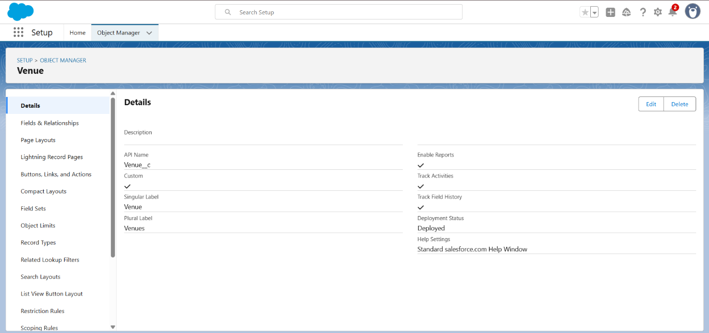

1. **Drop-Off Point:**

* Enter the label name >> Drop-Off Point
* Plural label name>> Drop-Off Points
* Enter Record Name Label and Format
* Record Name >> Drop-Off point Name
* Data Type >> Text

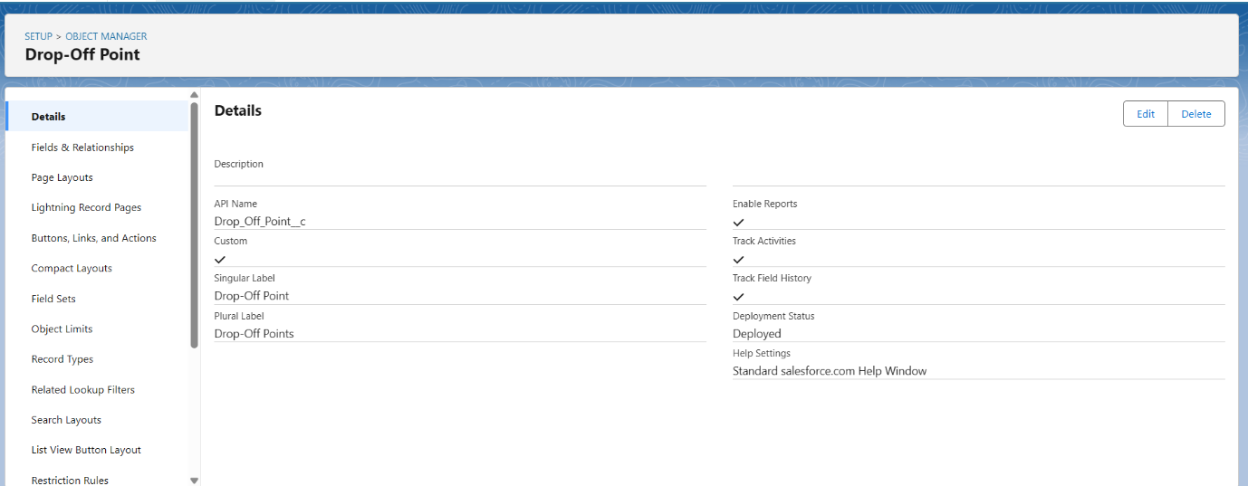

1. **Task:**

* Enter the label name>> Task
* Plural label name>> Tasks
* Enter Record Name Label and Format
* Record Name >> Task Name
* Data Type >> Text

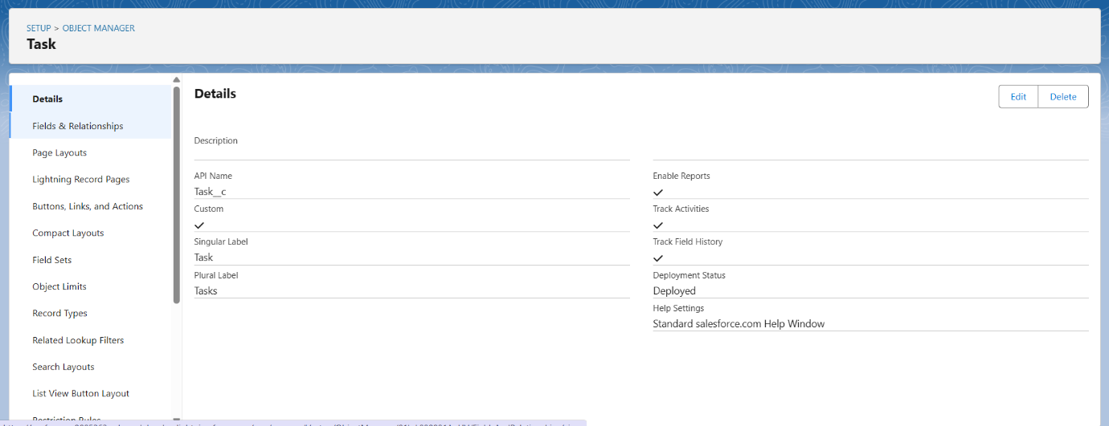

1. **Volunteer:**

* Enter the label name>> Volunteer
* Plural label name>> Volunteers
* Enter Record Name Label and Format
* Record Name >> Volunteer Name
* Data Type >> Text

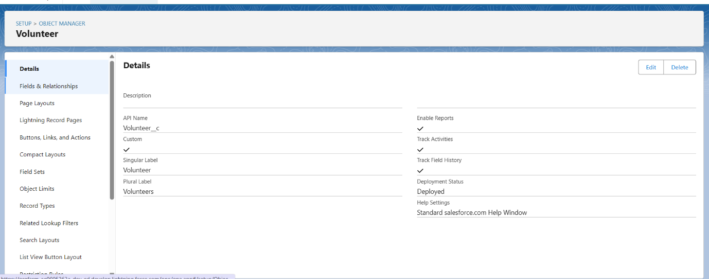

1. **Execution Details:**

* Enter the label name >> Execution Detail
* Plural label name >> Execution Details
* Enter Record Name Label and Format
* Record Name >> Execution Detail Name
* Data Type >> Text

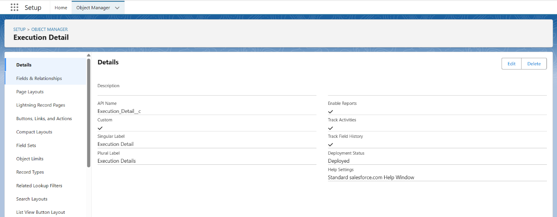

**Creation of Relationship fields in objects:**

Creation of Lookup Relationship Field on Volunteer Object:

1. Select Master Detail relationship
2. Field Name: Drop_Off_point
3. Field label: Auto generated

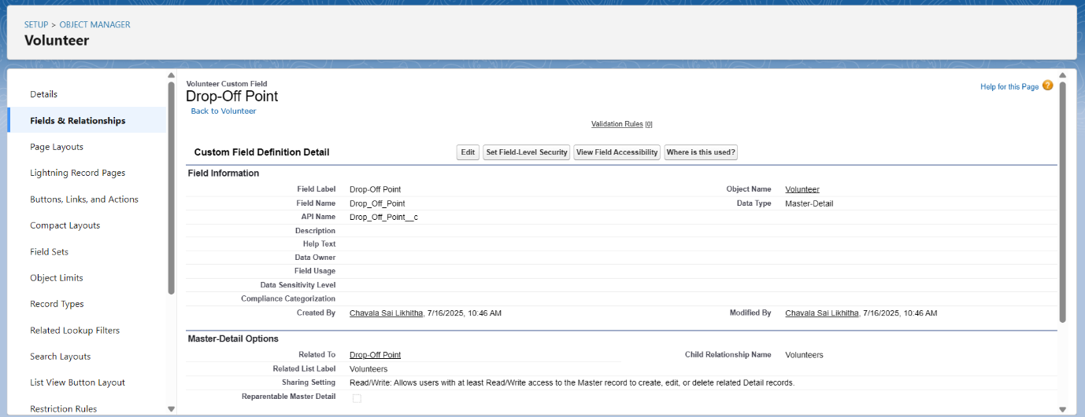

Creation of Master Detail Relationship Field on Execution Details Object:

1. Select Master Detail relationship
2. Field Name: Volunteer
3. Field label: Auto generated

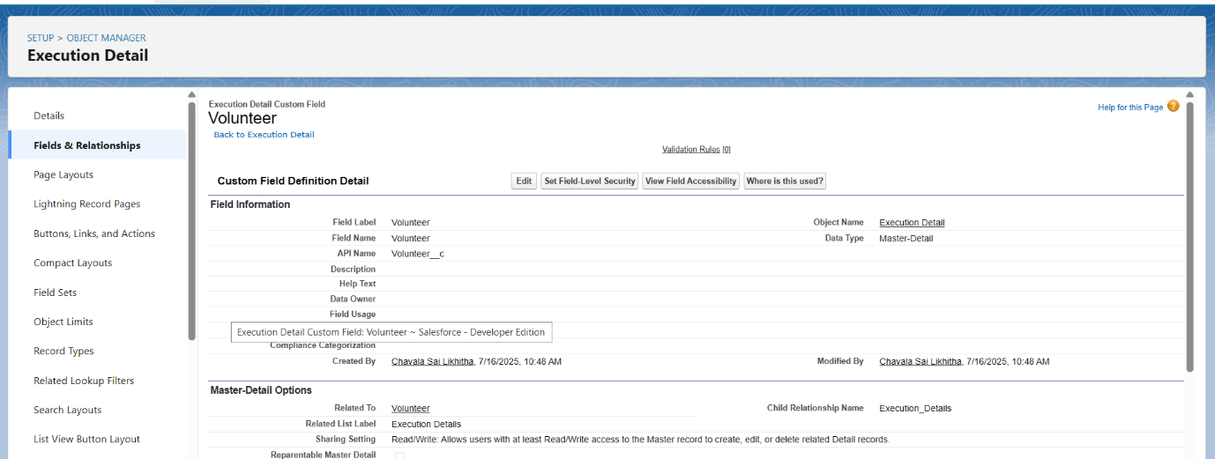

Creation of Master Detail Relationship Field on Execution Details Object:

1. Select Master Detail relationship
2. Field Name: Task
3. Field label: Auto generated

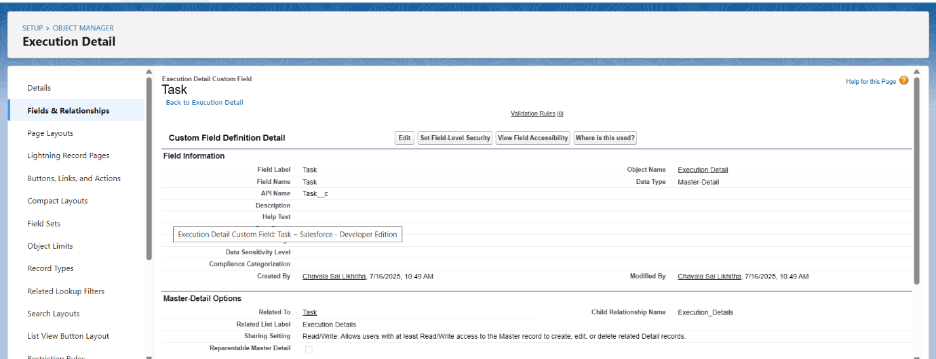

Creation of Lookup Relationship Field on Drop-Off Point Object:

1. Select Lookup relationship
2. Field Name: Venue
3. Field label: Venue__c

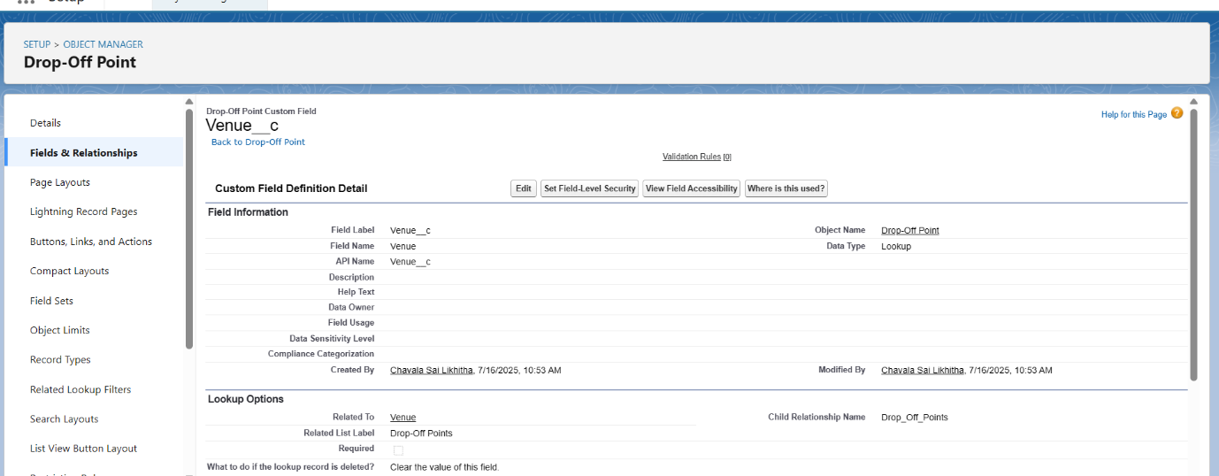

Creation of Lookup Relationship Field on Task Object:

1. Select Lookup relationship
2. Field Name: Sponsored By
3. Field label: Auto generated

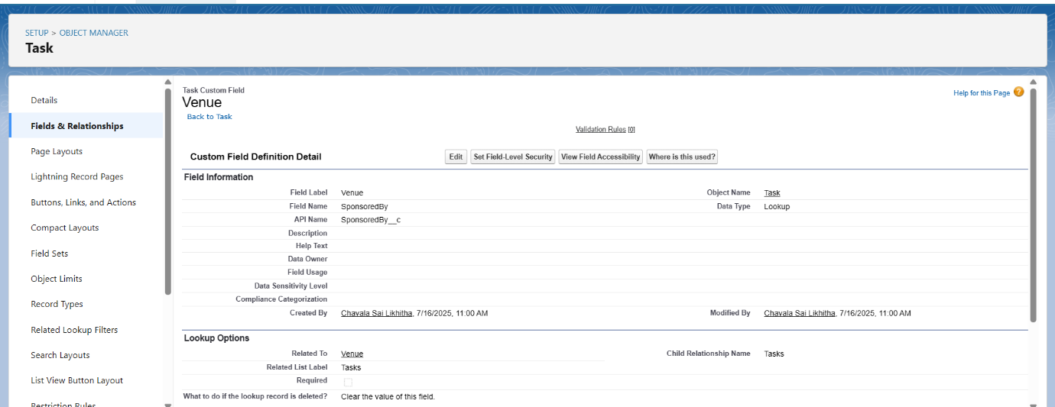

Creation of Lookup Relationship Field on Task Object:

1. Select Lookup relationship
2. Field Name: Drop-Off point
3. Field label: Auto generated

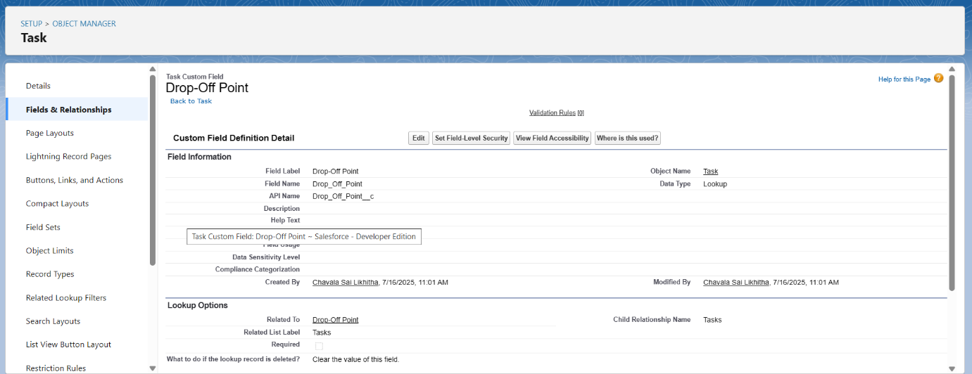

**Creation of fields for the Venue object:**

Email field:

1. Data Type: Email
2. Field Label: Contact Email
3. Field Name: Contact Email
4. Click on required check box

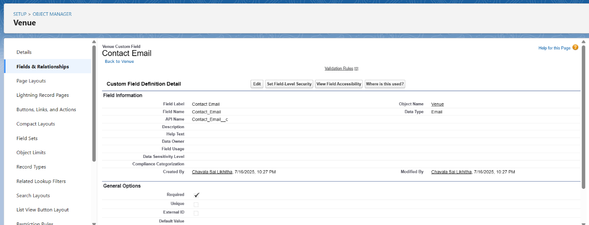

Phone field:

1. Data Type: Phone
2. Field Label: Contact Phone
3. Field Name: Contact Phone
4. Click on required check box

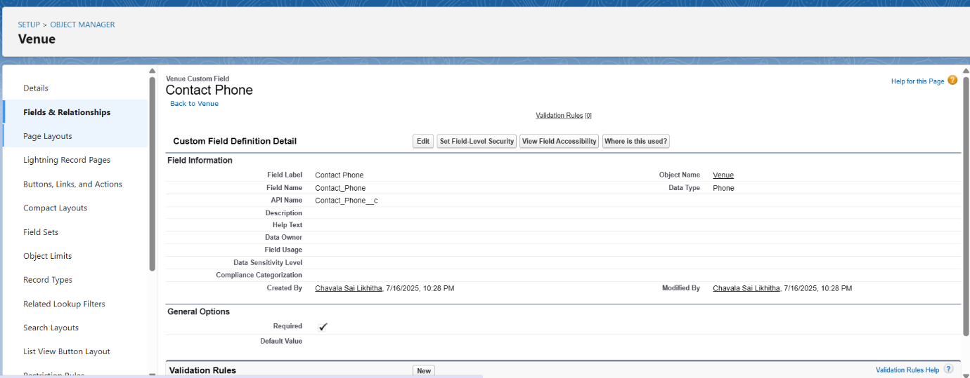

Location field:

1. Field Label: Location
2. Decimal Places: 4
3. Field Name: Location
4. Description: Enter the Geolocation of your Venue

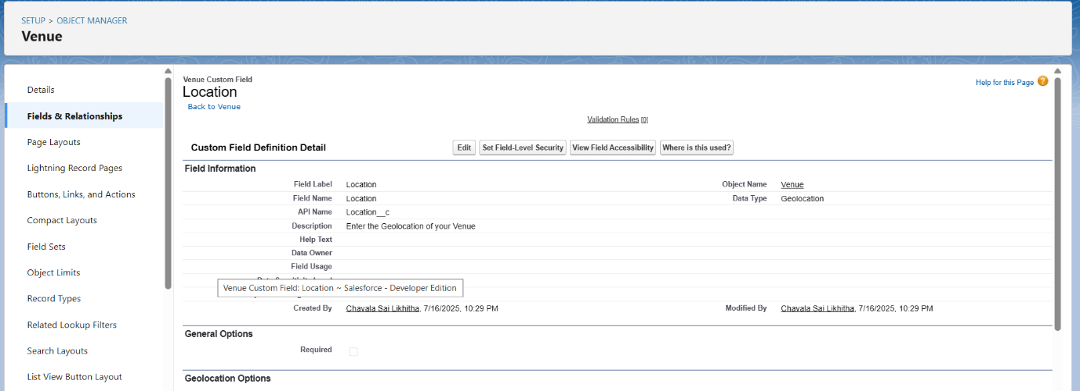

**Creation of fields for the Drop-Off point object:**

Location field:

1. Field Label: Location 2
2. Field Name: gets auto generated
3. Description: Enter the Geolocation of the Drop off Point
4. Geolocation Options: select Decimal
5. Decimal Places: 4

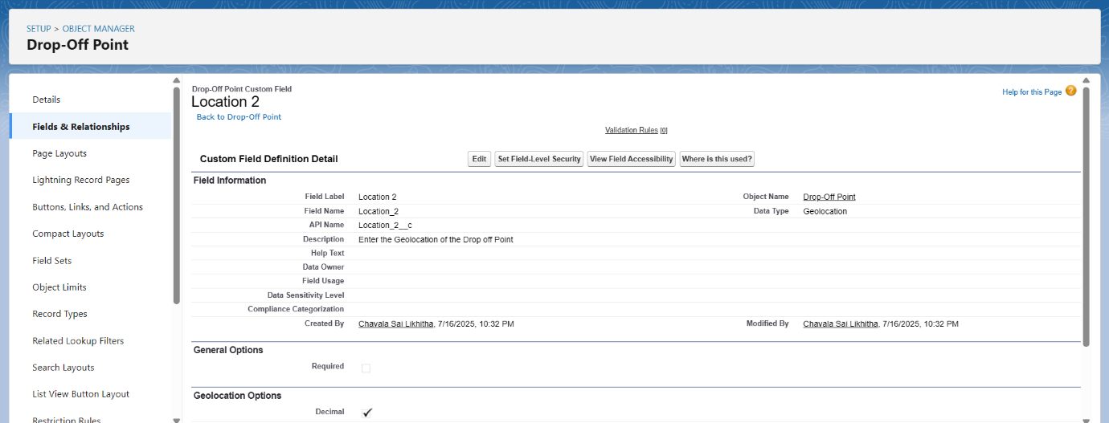

Distance calculation field:

1. Field Label: distance calculation
2. Field Name: distance_calculation
3. Formula Return Type: Number
4. Formula Options: DISTANCE (Location_2__c ,  Venue__r.Location__c , 'km')

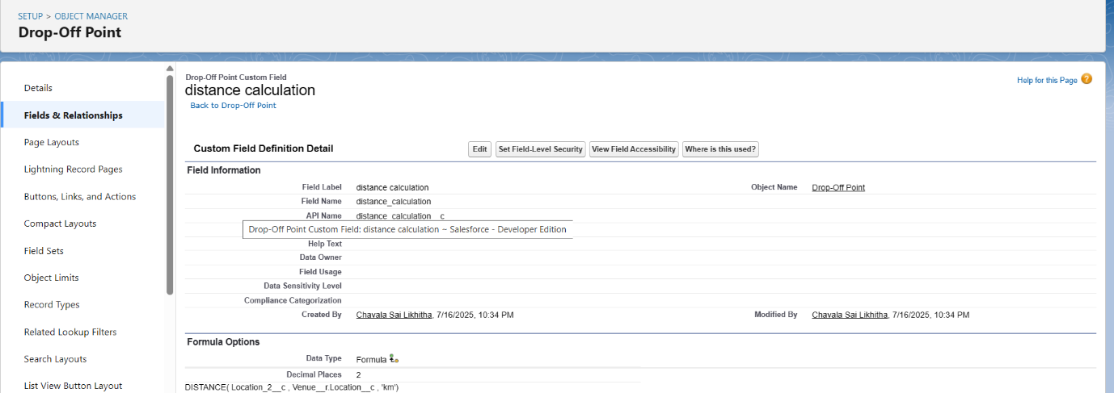

State field:

1. Field Label: State
2. Field Name: State
3. Enter values, with each value separated by a new line:

* Andhra Pradesh
* Arunachal Pradesh
* Assam
* Bihar
* Chhattisgarh
* Goa
* Gujarat
* Haryana
* Himachal Pradesh
* Jharkhand
* Karnataka
* Kerala
* Maharashtra
* Madhya Pradesh
* Manipur
* Meghalaya
* Mizoram
* Nagaland
* Odisha
* Punjab
* Rajasthan
* Sikkim
* Tamil Nadu
* Tripura
* Telangana
* Uttar Pradesh
* Uttarakhand
* West Bengal
* Andaman & Nicobar (UT)
* Chandigarh (UT)
* Dadra & Nagar Haveli and Daman & Diu (UT)
* Delhi [National Capital Territory (NCT)]
* Jammu & Kashmir (UT)
* Ladakh (UT)
* Lakshadweep (UT)
* Puducherry (UT)

1. Click on required check box

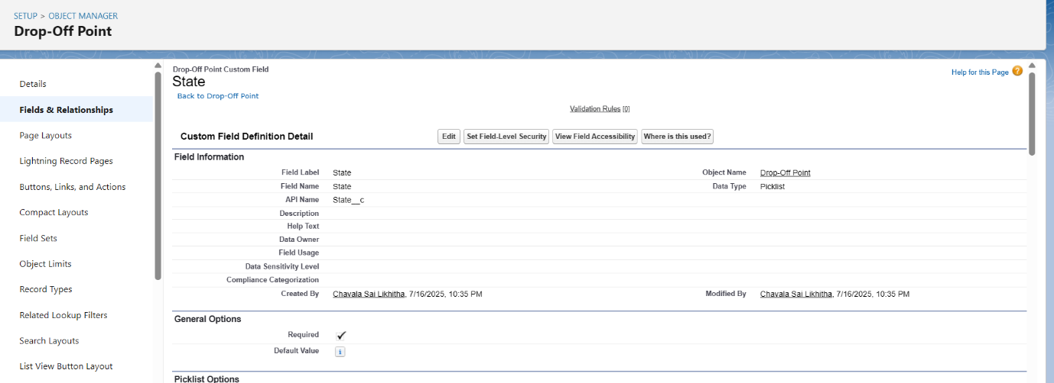

Distance field:

1. Field Label: Distance
2. Field Name: Distance
3. Length: 14
4. Decimal Places: 4
5. Click on required check box

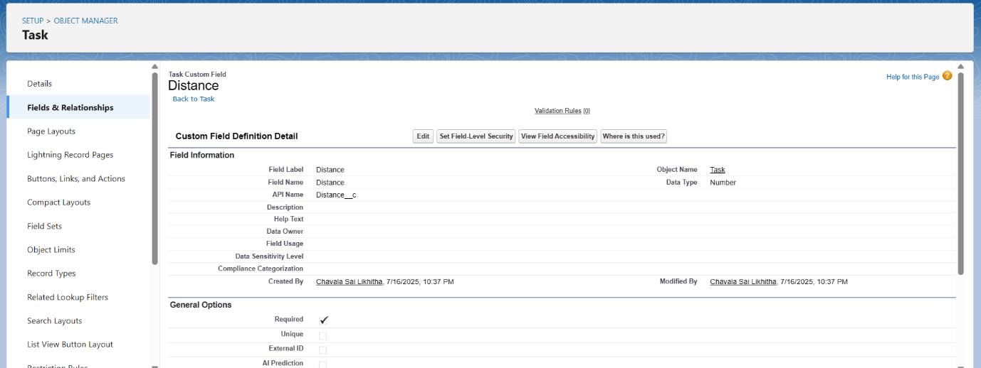

**Creation of fields for the Task object:**

Task ID field:

1. Field Label: Task ID
2. Display Format: TASK-{0}
3. Starting Number: 1
4. Field Name: gets auto generated
5. Click on required check box

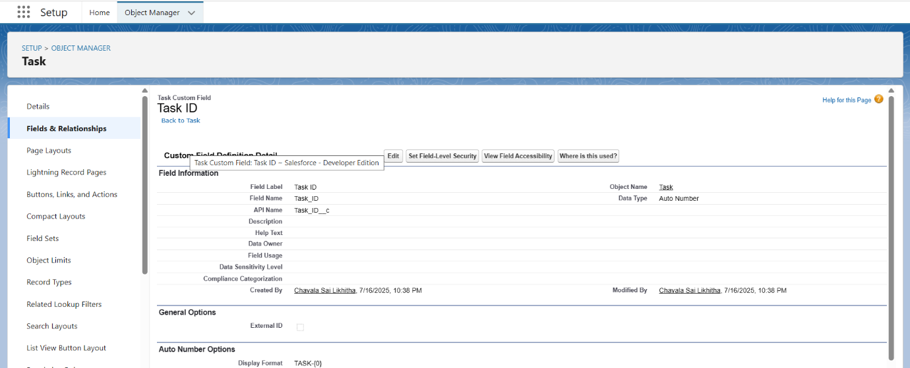

Date field:

* Field Label: Date
* Field Name: Date
* Click on required check box

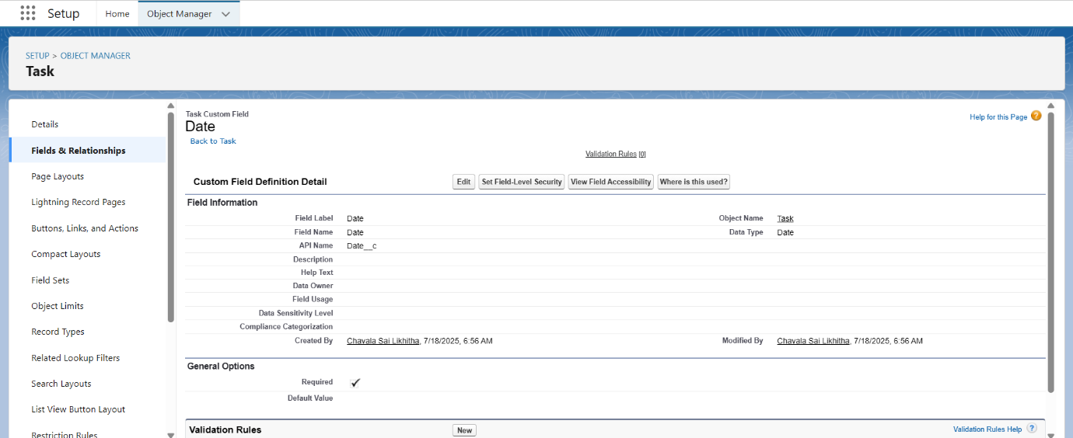

Food Category field:

1. Field Label: Food Category
2. Field Name: Food Category
3. Enter values, with each value separated by a new line:

* Veg
* Non-Veg
* Salad
* Snack

1. Click on required check box

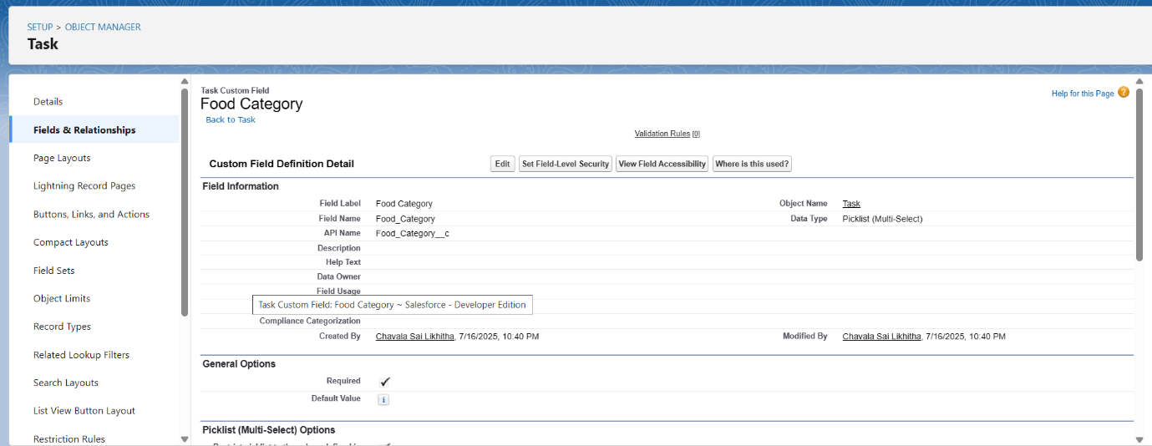

Rating field:

1. Field Label: Rating
2. Field Name: Rating
3. Enter values, with each value separated by a new line:

* 1
* 2
* 3
* 4
* 5

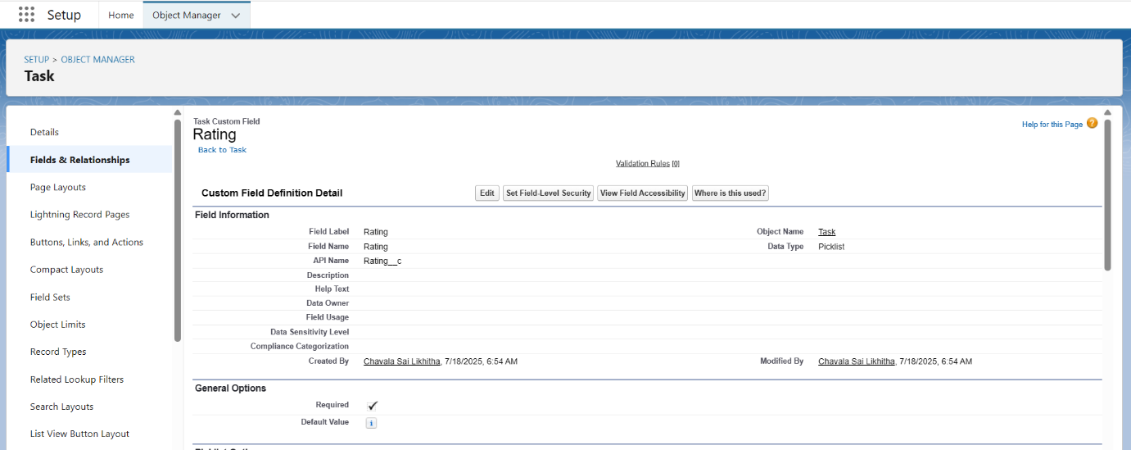

Feedback field:

1. Data Type: long text area
2. Field Label: Feedback
3. Field Name: Feedback

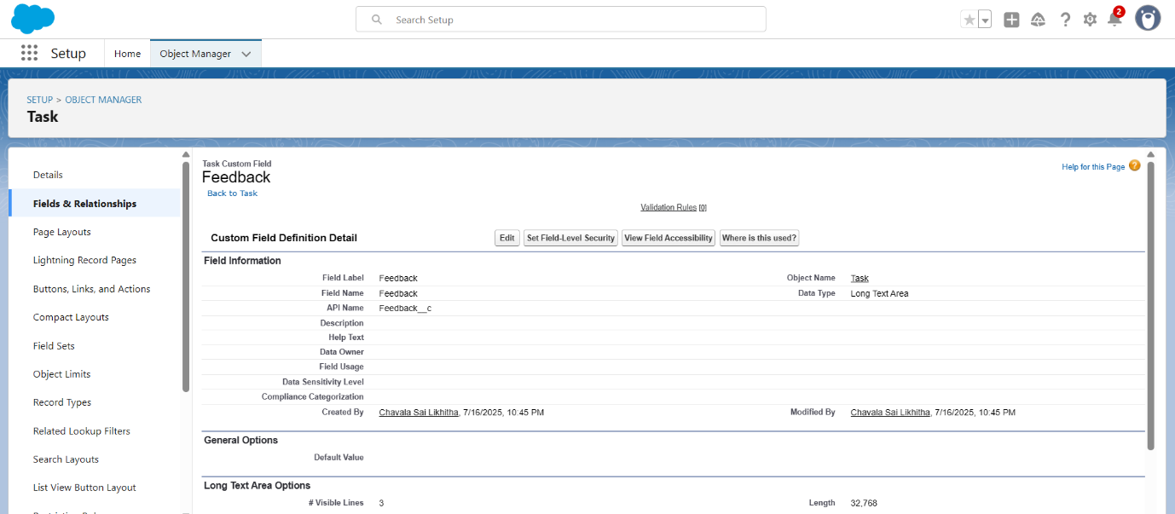

**Creation of fields for the Volunteer object:**

Volunteer ID field:

1. Field Label: Volunteer ID
2. Field Name: gets auto generated
3. Click on required check box

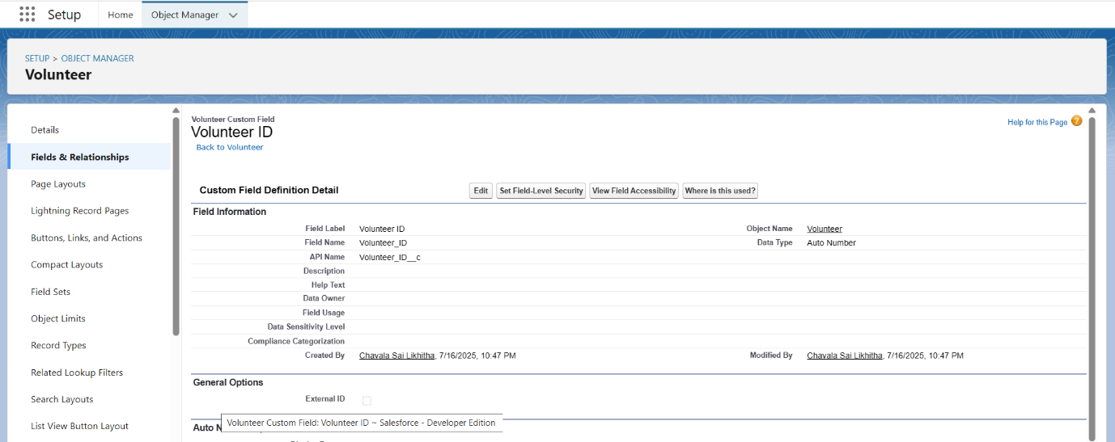

Gender field:

1. Field Label: Gender
2. Field Name: Gender
3. Enter values, with each value separated by a new line:

* Female
* Male

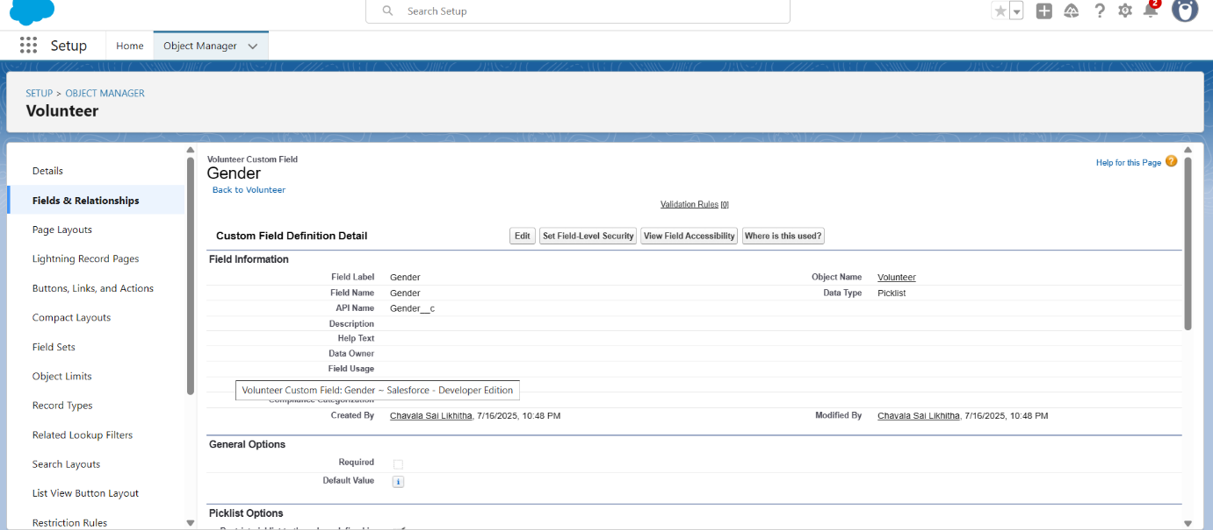

Available On field:

1. Field Label: Available On
2. Field Name: Available On
3. Click on required check box

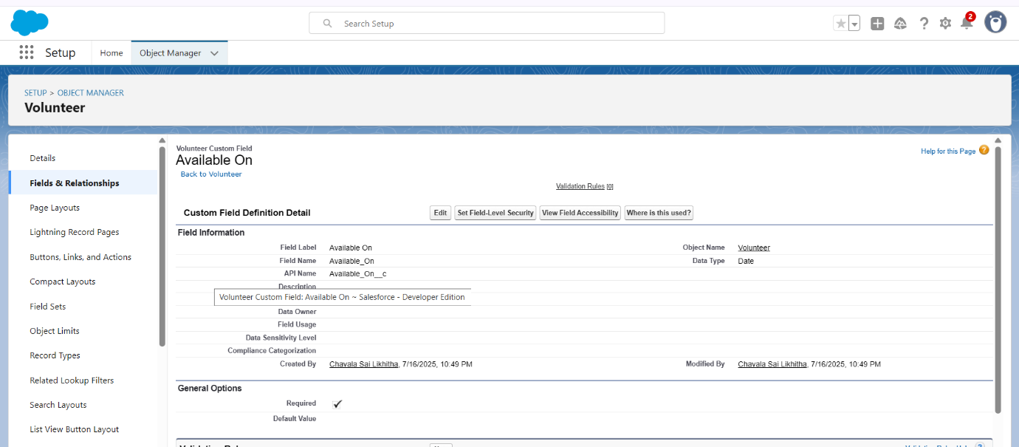

Age field:

1. Field Label: Age
2. Field Name: Age
3. Click on required check box

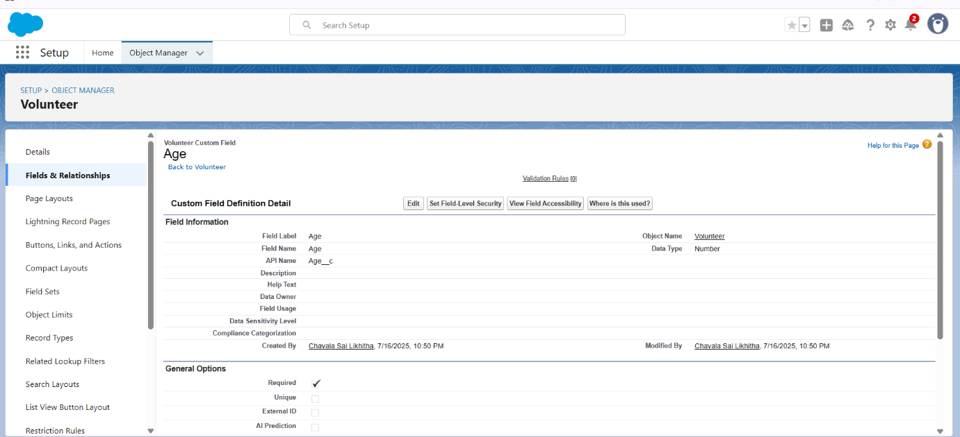

Contact label:

1. Field Label: Contact Number
2. Field Name: Contact_Number
3. Click on required check box

Address field:

1. Data Type: Text Area (Long)
2. Field Label: Address
3. Field Name: Address

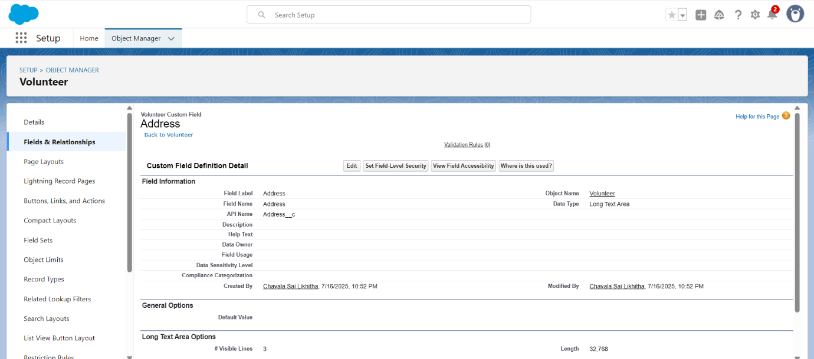

DOB field:

1. Data Type: Date
2. Field Label: Date of Birth
3. Field Name: Date_of_Birth

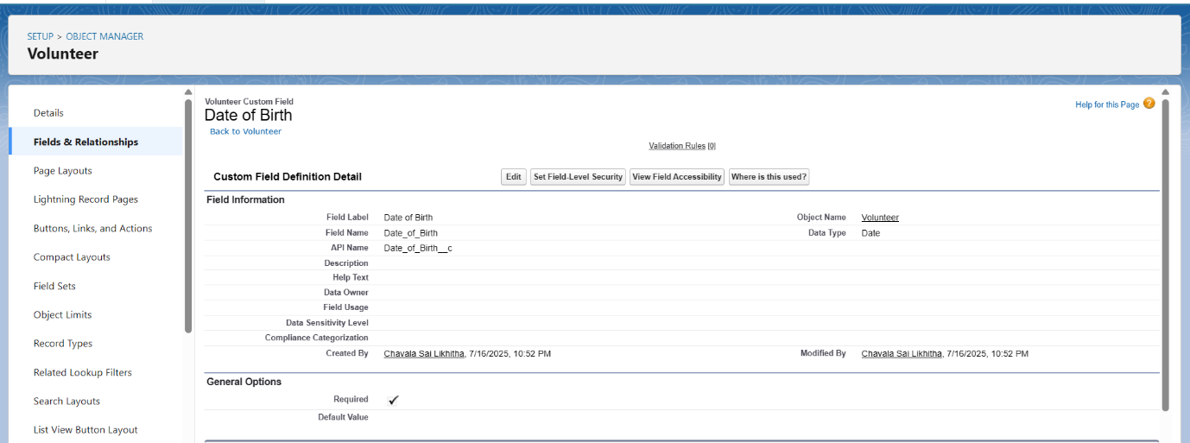

**Creation of fields for the Execution Details object:**

* Field Label: Execution ID
* Field Name: gets auto generated
* Click on required check box

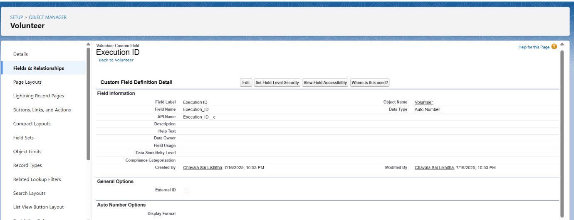

**Create Flow to create a record in Venue object:**

1. Select the Screen flow. Click on create.
2. Under the Screen Properties:
   1. Label: Venue Details
   2. API Name: Venue_Details
3. Now let’s add components in this flow. Click on Text Component and name it as:
   1. Label: Venue Name
   2. API Name: Venue_Name
4. Click on Email Component and name it as:
   1. Label: Email
   2. API Name: Contact_Email
5. Click on Phone Component and name it as:
   1. Label: Phone
   2. API Name: Contact_Phone
6. Click on Text Component and name it as:
   1. Label: Venue Location
   2. API Name: Venue_Location
7. Click on Number Component and name it as:
   1. Label: Latitude
   2. API Name: Latitude
8. Click on Number Component and name it as:
   1. Label: longitude
   2. API Name: longitude

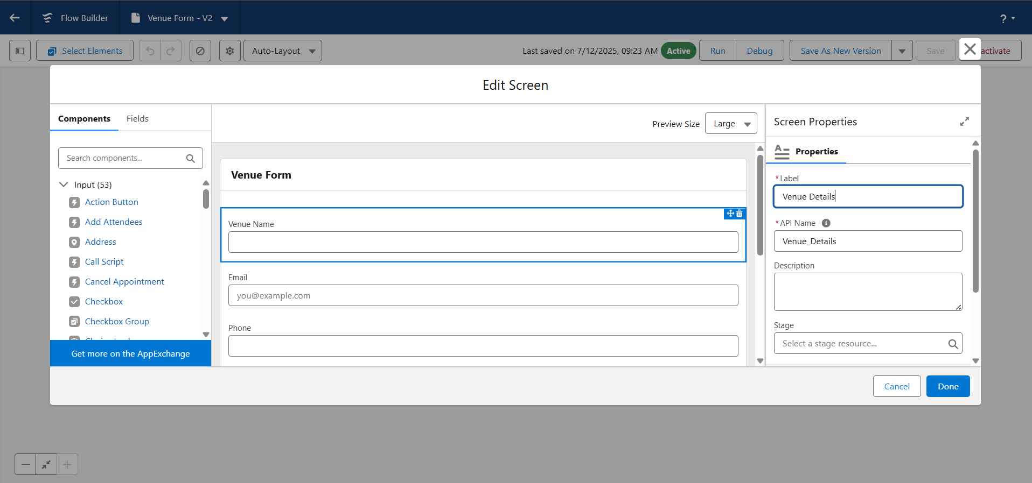

1. Now label it as:

Label: Create Venue Record

API Name: Create_Venue_Record

How Many Records to Create: One

How to Set the Record Fields: Use separate resources, and literal values

Object: Venue

Set Field Values for the Venue: Click on ‘Add Field’ 5 times

Field: Value = Contact_Email__c: {!Contact_Email.value}

Field: Value = Contact_Phone__c: {!Contact_Phone.value}

Field: Value = Name: {!Venue_Name}

Field: Value = Venue_Location__c: {!location}

Field: Value = Location__Latitude__s: {!latitude}

Field: Value = Location__Longitude__s: {!longitude}

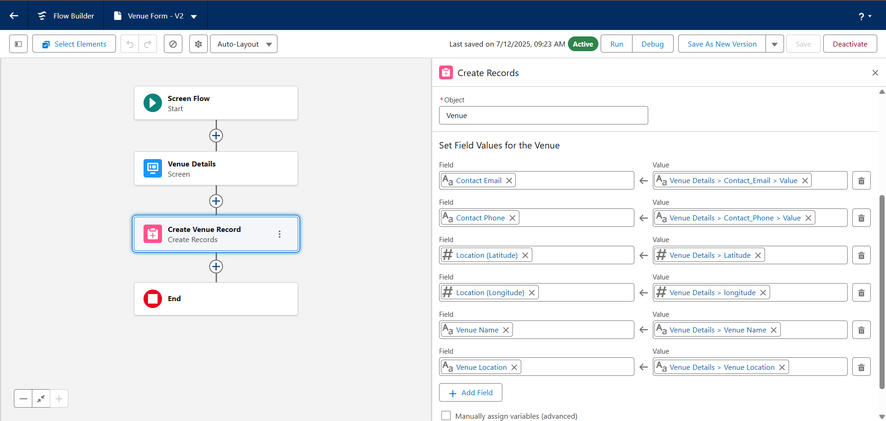

1. Click on Save as:
2. Flow Label: Venue Form
3. Flow API Name: Venue_Form

**Create a Trigger:**

1. Click on developer console and you will be navigated to a new console window.
2. Click on the File menu in the toolbar, and click on new >> Trigger.
3. Enter the trigger name and the object to be triggered.

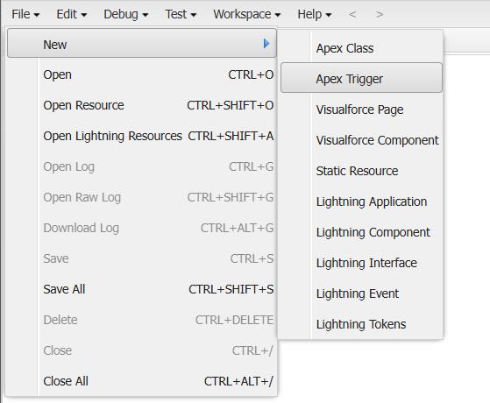

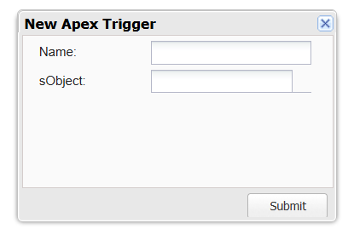 Enter Name: DropOffTrigger

sObject: Drop-Off Point

Click on Submit.

**Trigger Code:**

trigger DropOffTrigger on Drop_Off_point__c (before insert) {

    for(Drop_Off_point__c Drop : Trigger.new){

        Drop.Distance__c = Drop.distance_calculation__c;

    }

}

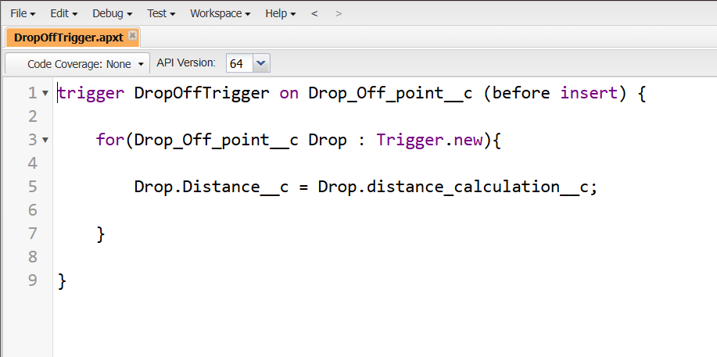

Phase 3:UI/UX Development and customization:

To create a lightning app page:

Go to setup page >> search “app manager” in quick find >> select “app manager” >> click on New lightning App.

Fill the app name in app details and branding as follow  
App Name : FoodConnect  
Developer Name : This will auto populated  
Image : optional (if you want to give any image you can otherwise not mandatory) Primary color hex value : keep this default.

.Then click Next  >> (App option page)Set Navigation Style as Standard Navigation >> Next.

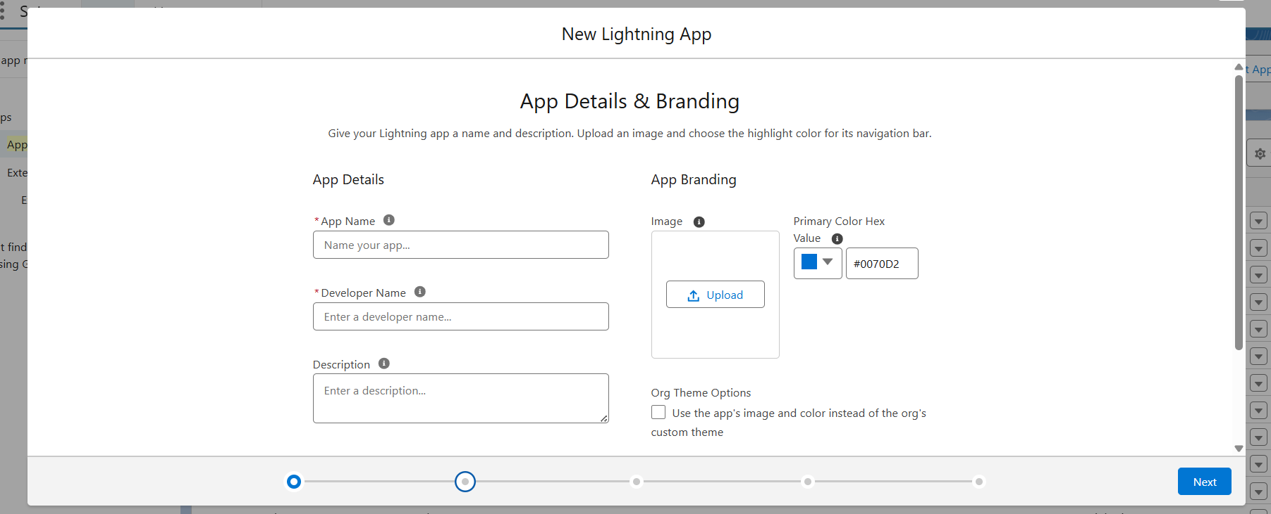

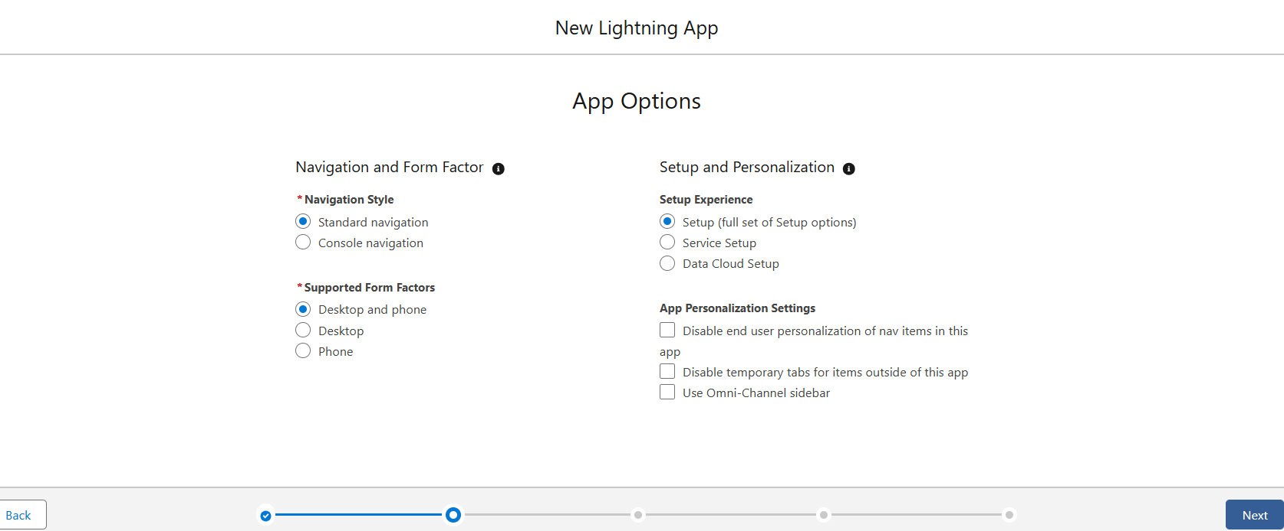

Search for the item in the (Home, Venue, Drop-Off Point, Task, Volunteer, Execution Details, Reports) from the search bar and move it using the arrow button >> Next >> Next.

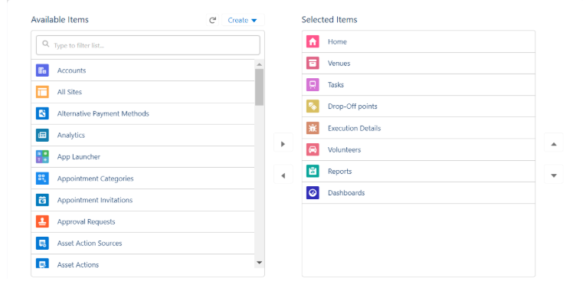

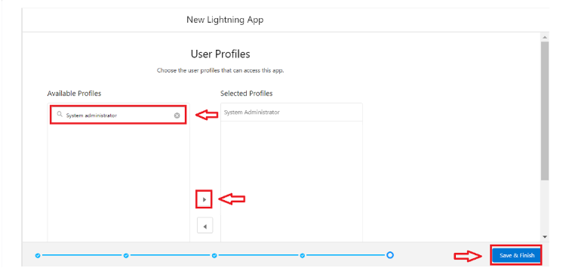

Search profiles (System administrator) in the search bar >> click on the arrow button >> save & finish.

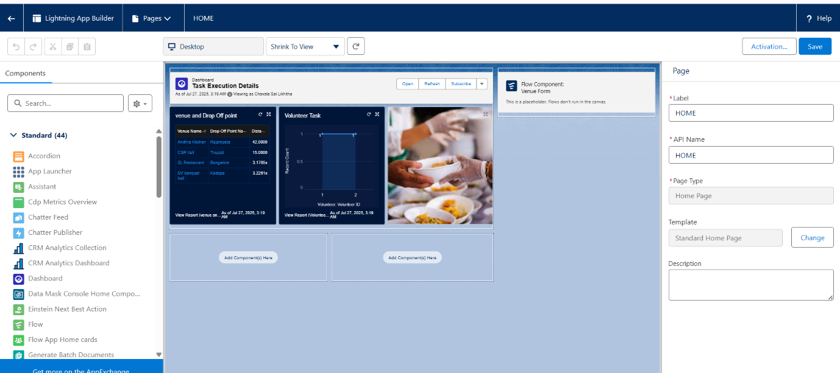

User Management:

1. Go to setup page >> type users in Quick Find bar >> click on users>> New user.
2. In General Information give details as: (Note: create users as per your wish NGO’s)

First Name: Iksha Foundation

Last Name: Iksha_Foundation

Alias: iiksh

Email: Give Your Email

Username: [ikshafoundation@sb.com](mailto:ikshafoundation@sb.com) (give the username different)

Nickname: Auto Populated

User License: Salesforce Platform

Profile: NGOs Profile

Active: Check



Reports:

1. Go to setup page  >>  type Report Types in Quick Find bar  >> click on Report Types  >>  click on Continue   >>  Click on New Custom Report Type.
2. In Define the Custom Report Type:
   1. Primary Object: Select Venues
   2. Report Type Label: Venue with DropOff with Volunteer
   3. Report Type Name: Venue_with_DropOff_with_Volunteer
   4. Description: Venue with DropOff with Volunteer
   5. Store in Category: Select Other Reports
   6. Deployment Status: Deployed
3. Click on Next
4. Near Click to relate another Object Select Drop-Off Points.
5. And also select "A" records may or may not have related "B" records.
6. Now again Near Click to relate another Object Select Volunteers.
7. Now click on Save.

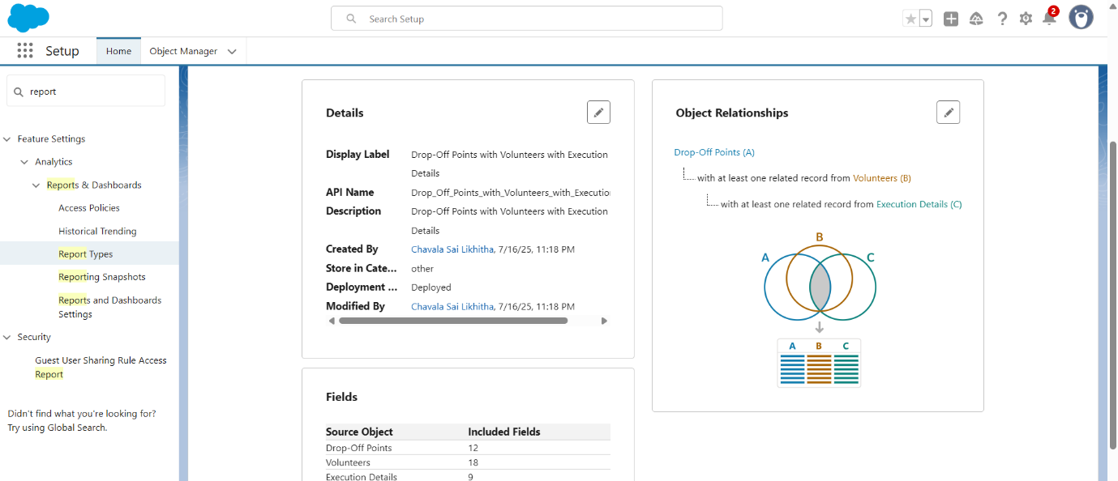

Creation of report:

Creation of Report on Venue with DropOff with Volunteer:

1. Go to the app(FoodConnect)  >>  click on the reports tab
2. Click on New Folder.
3. Folder Label: Custom Reports
4. Folder Unique Name: CustomReports
5. Open Custom Reports and click on New Report
6. Select Report Type: Venue with DropOff with Volunteer
7. Then click on Start Report.
8. In GROUP ROWS: Add Volunteer Name
9. In Columns: Add Venue Name, Drop-Off point Name, Distance.
10. Now click on Save & Run.
11. Give Label as:
12. Report Name: venue and Drop Off point
13. Report Unique Name: Auto Populated
14. Click on Select Folder and select Custom Report, then click on Save.

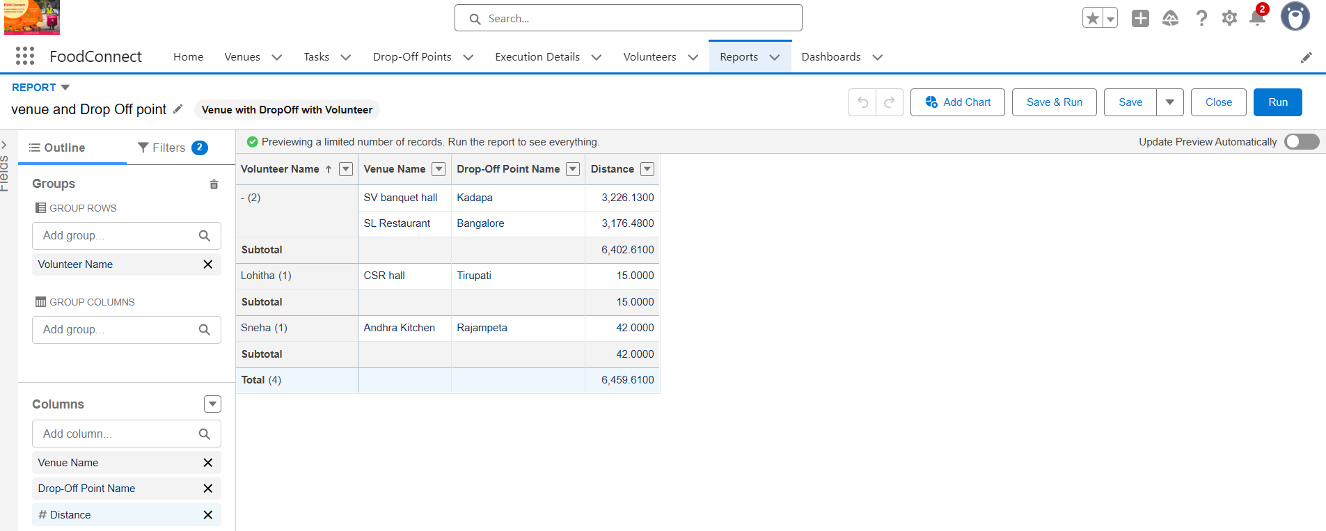

**Creation of Report on Volunteers with Execution Details and Tasks:**

1. Go to the app(FoodConnect)  >>  click on the reports tab
2. Click on Custom Reports Folder and click on New Report
3. Select Report Type: Volunteers with Execution Details and Tasks.
4. Then click on Start Report.
5. In GROUP ROWS: Volunteer ID
6. In Columns: Add Volunteer: Volunteer Name, Task: Task Name, Execution Detail: Execution Detail Name, Volunteer: Owner Name, Task: Date, Task: Rating.
7. Now click on Save & Run.
8. Give Label as:
9. Report Name: Volunteer Task
10. Report Unique Name: Auto Populated
11. Click on Select Folder and select Custom Report, then click on Save.

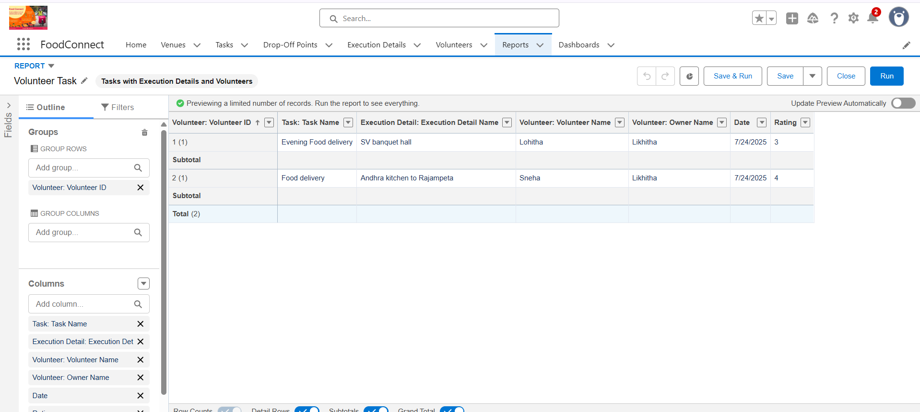

Dashboards:

Adding venue and Drop Off point Report to the Dashboard:

1. Go to the app(FoodConnect)  >>  click on the Dashboards tab.
2. Click on New Folder.
3. Folder Label : Custom Dashboards
4. Folder Unique Name : Auto Populated
5. Open Custom Dashboards and click on New Dashboards
6. Name : Organization Details
7. Click on Widget and select Chart or Table
8. In Select Report : Select venue and Drop Off point Report.
9. Then click on select
10. In Add Component:
11. Display As : Select Lightning Table

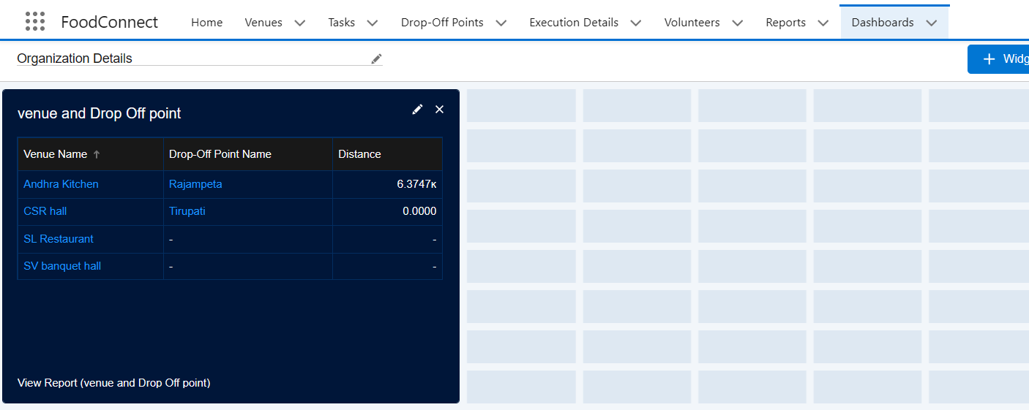

Adding Volunteer Task Report to the Dashboard:

1. Click on Widget and select Chart or Table
2. In Select Report : Select Volunteer Task Report.
3. Then click on select
4. In Add Component:
5. Display As : Select Line Chart

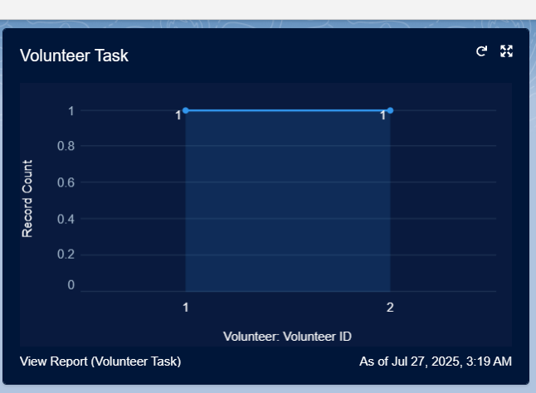

1. Now click on save.

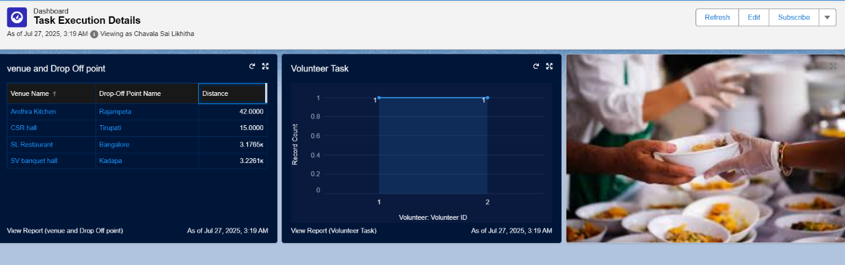

Profiles, Role, Role Hierarchy, Permission Sets, Sharing Rules:

In a CRM system, users are individuals who access the platform, each assigned a profile that defines what they can see and do—such as object-level permissions, field visibility, and app access. Roles establish a user's position within the role hierarchy, which determines data access—higher roles inherit access from lower ones, enabling visibility across teams. Sharing rules extend access beyond role-based settings, allowing broader collaboration by automatically sharing records with groups or roles based on criteria. Permission sets provide extra privileges layered onto profiles for flexibility, letting admins tailor access without altering base settings. Together, these elements form a secure and scalable access model that balances control and collaboration across an organization.

Profiles:

1. Go to setup page >> type Profiles in Quick Find bar >> click on Profiles >> click on ‘S’
2. Click on Clone beside Standard Platform User.
3. Under Clone Profile:

Profile Name: NGOs Profile

1. Then click on Save.

Creation of sharing rules:

1. Go to setup >> type Sharing Settings in quick find box >>  Click on the Sharing Settings.
2. Scroll down and find Drop-Off point Sharing Rules.
3. Click on new near Drop-Off point Sharing Rules and Name it as:

Label: Rule 1

Rule Name: Rule_1

1. Select your rule type: Select Based on criteria.
2. Select which records to be shared:

Field: Operator: Value = Distance: less than: 15

1. Select the users to share with: Near Share With

Public Groups: Iksha

1. Click on Save.
2. Click on new near Drop-Off point Sharing Rules and Name it as:

Label: Rule 2

Rule Name: Rule_2

1. Select your rule type: Select Based on criteria.
2. Select which records to be shared:

Field: Operator: Value = Distance: greater than: 15

Field: Operator: Value = Distance: less or equal: 30

1. Select the users to share with: Near Share With

Public Groups: NSS

1. Click on Save.
2. Click on new near Drop-Off point Sharing Rules and Name it as:

Label: Rule 3

Rule Name: Rule_3

1. Select your rule type: Select Based on criteria.
2. Select which records to be shared:

Field: Operator: Value = Distance: greater than: 30

Field: Operator: Value = Distance: less or equal: 50

1. Select the users to share with: Near Share With

Public Groups: Street Cause

1. Click on Save.

**Phase 5: Deployment, Documentation & Maintenance**

**Deployment Strategy:**

Change Sets were used to deploy the FOODCONNECT CRM from the sandbox environment to production. This allowed for the safe and systematic migration of metadata components, such as custom objects, fields, validation rules, flows, and Apex code. By ensuring that all dependencies were appropriately packed and tested prior to final deployment, this approach reduced the possibility of live environment disturbances.

**System Maintenance and Monitoring:**

The CRM is made to be easily maintained over time. Dashboards and scheduled reports that highlight indicators like completed distributions and pending pickups aid in the monitoring of daily operations. The purpose of routine data quality assessments is to find discrepancies or duplication. Administrators are in charge of conducting routine evaluations of automation procedures and making sure that validation flows and rules remain in line with changing business needs. Before being deployed to production, any necessary improvements or new features will be securely developed and tested in sandbox conditions.

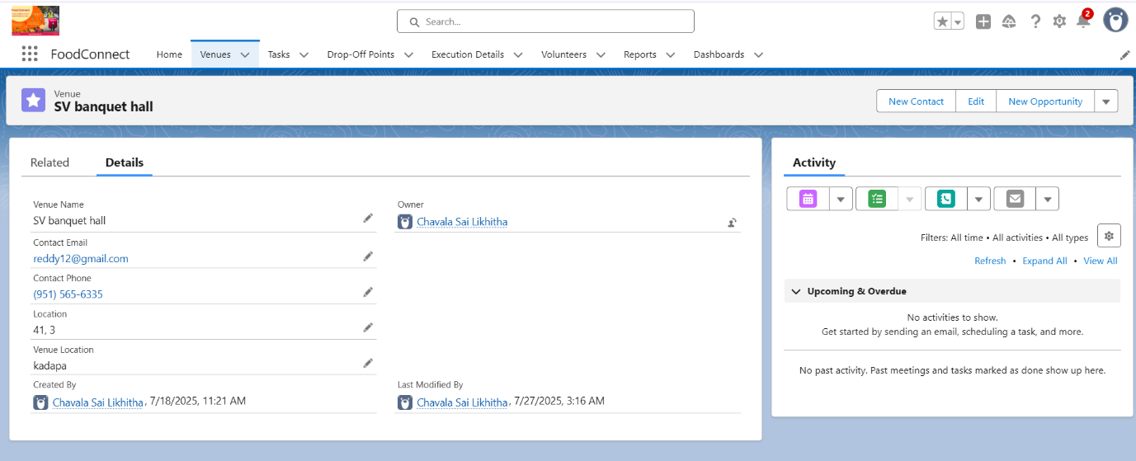

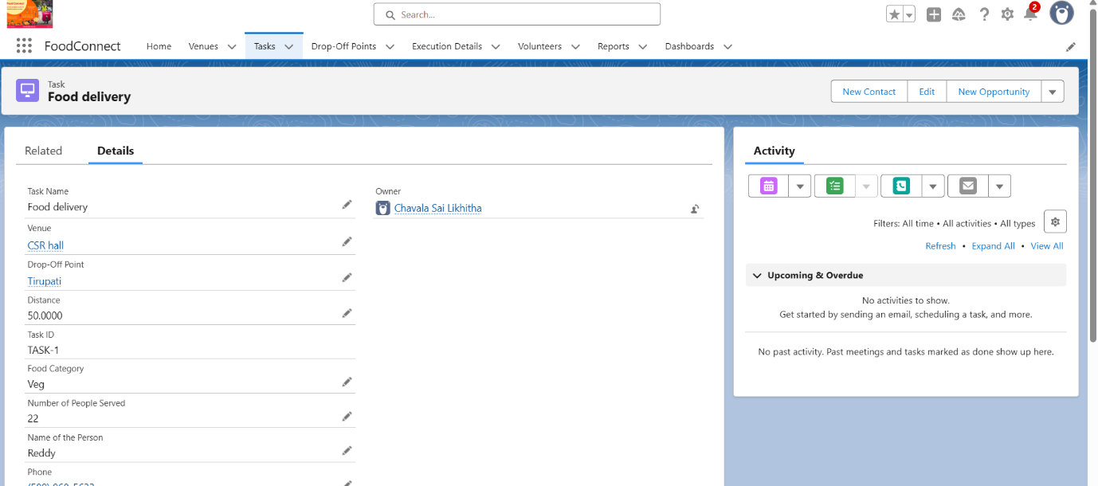

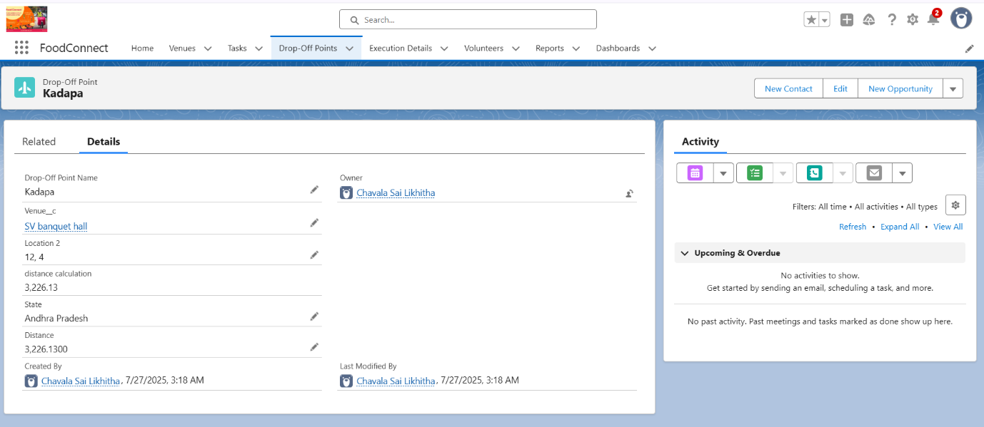

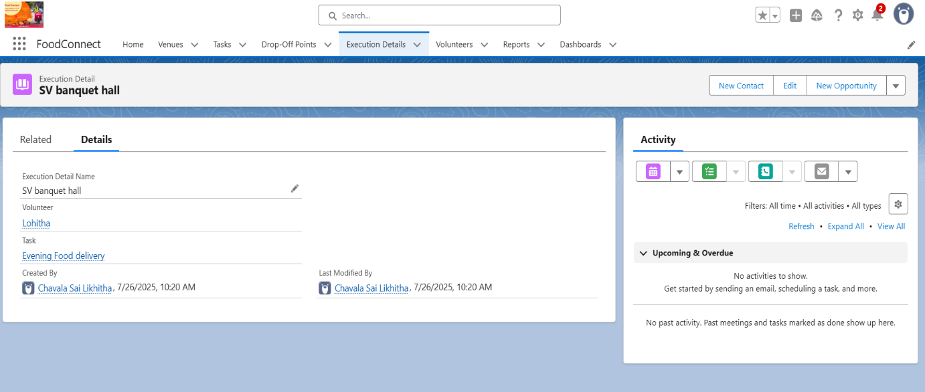

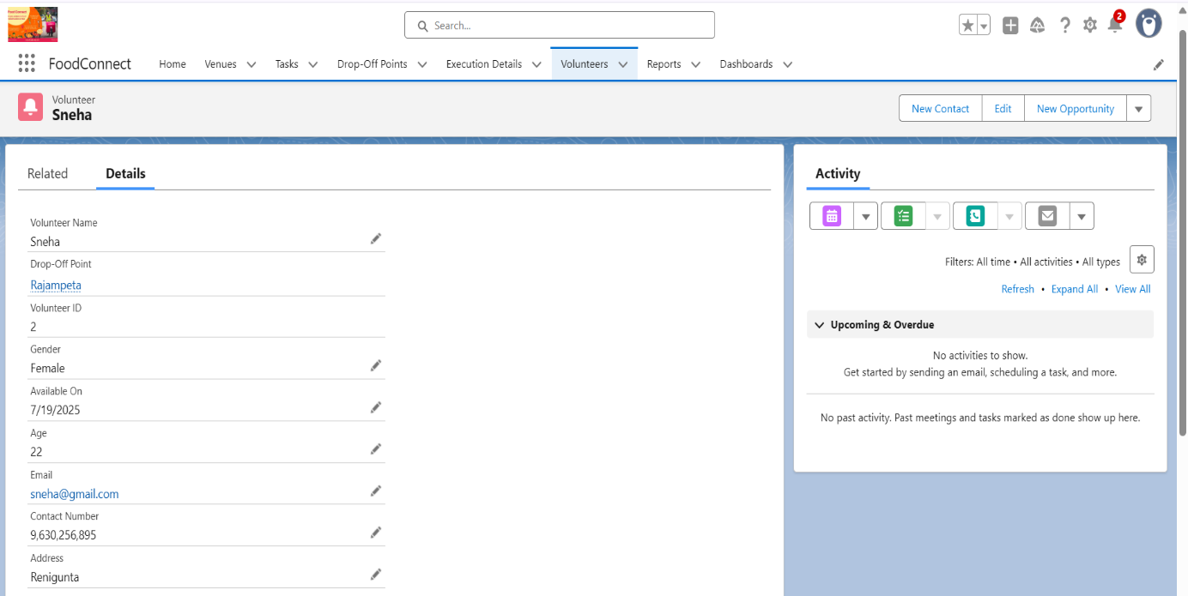

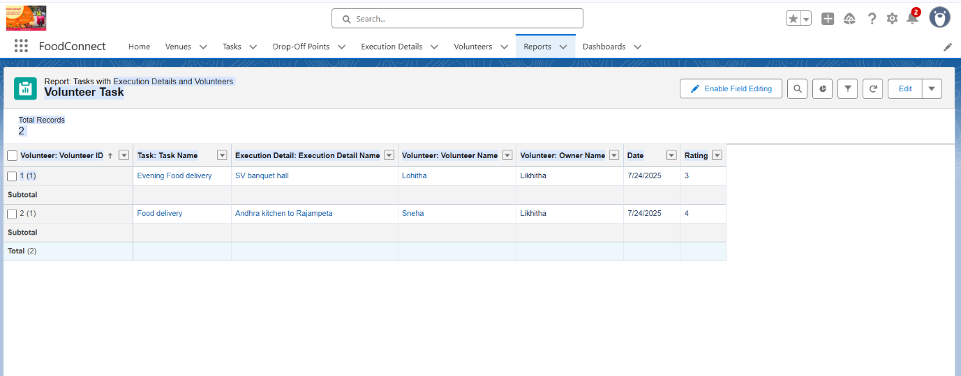

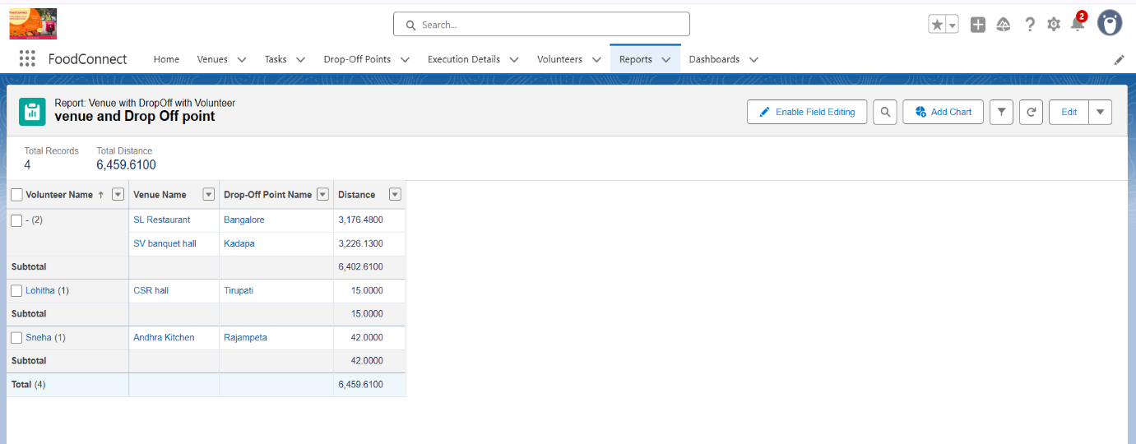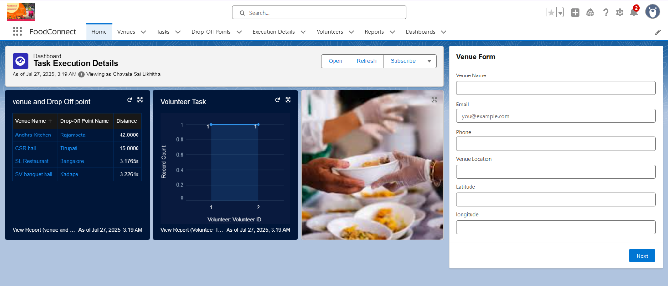

**Troubleshooting Approach:**

To guarantee seamless operations and reduce disturbances, a methodical troubleshooting procedure is implemented to tackle frequent problems including unsuccessful pickups, delayed notifications, and inconsistent data. By using debug logs to track down issues in Apex triggers and automation flows, technical teams may swiftly locate and fix the underlying causes of problems. Detailed CRM documentation, which describes object relationships, business rules, and known error signals, aids in this process. By ensuring that leftover food is provided to people in need on time, this proactive and methodical approach helps preserve system stability and supports the organization's aim of decreasing waste and combating hunger.

**Conclusion:**

The Food Connect initiative uses Salesforce CRM to build a dependable, expandable platform that links surplus food suppliers with underserved populations. The method minimizes food waste, cuts down on human labor, and guarantees that gifts reach the impoverished quickly and effectively by automating crucial procedures including food collection, scheduling, and distribution. Through automated donor communication, comprehensive data recording, and real-time dashboards, it also enhances transparency and operational supervision. Food Connect is built to develop, offering a versatile platform to bring on more volunteers, NGOs, and donors as the network grows. Going forward, the platform has a lot of room for innovation, such as chatbot-enabled donor support and AI-powered demand forecasts, which would help it in its efforts to end hunger and assist marginalized populations.